**TASK 5**

**Create a BRD document with the first page and the Table of content.**

**See another file attached.**

**What is Risk Analysis in BRD and how do we mention it?**

Risk Analysis is the process to identify and analyse potential issues which could negatively affect the important business attributes. We categorise the risk in by priority and impact level. High priority, medium priority and low priority. Similarly, high, medium and low impact. Depending on the threat level, action is taken to mitigate the impact on business.   
We can also create a risk matrix based on the severity to analyse the scenario.   
  
E.g.

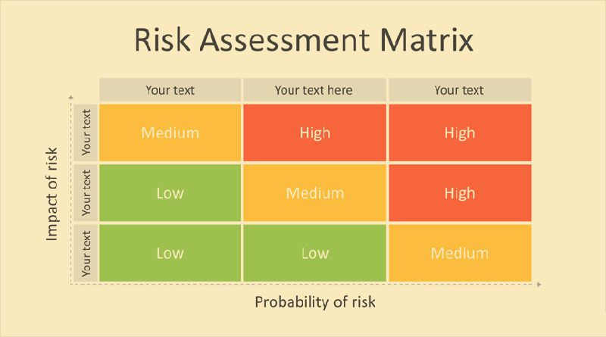

Source : <https://www.namasteui.com/risk-assessment-matrix-what-is-it/>

**What is Project Scope and Project Objective?**

**A Project Scope** is a tool used for describing major deliverables of a project. It includes all the key milestones, constraints, important requirements, deadlines, etc. From the project scope the team gets a guideline for making decisions about change requests during the project.

**A Project Objective** is the desired outcome statement of the project defined during the initiation of the project. Project Objective should be clearly stated to all the team members including the stakeholders for better and clear communication.

**What is the Role and Responsibilities of the Product Owner and Product Manager?**

A Product Owner role is representing the customer to the development team. Product Owner main role is to make the product backlog visible, or prioritized list of requirements for future product development. The product owner should always be available to answer any questions the team member is having with their customers.  
   
 Some of the responsibilities are:  
 Ensure user stories are ready for development to start work.  
 Ensure each stories has proper acceptance criteria.  
 Prioritizes the product backlog.  
 Should have technical expertise, domain specific.  
  
 A Product Manager is responsible for product planning and execution through the product lifecycle. A Product Manager works closely with engineering, sales, marketing and support to ensure customer satisfaction goals are met.   
   
 Some of responsibilities are:  
 Manager from concept, to design, sample production, testing, forecast, cost, promotion, support and finally end of project life.   
 Deliver the Operating plan such as revenue, profit, ROI for all categories of business/ customers.   
 Responsible for manging and implementing marketing activities through research, analysis, planning and implementation.

**Write down the difference between BRD vs FRD vs SRS (in detail)**

|  |  |  |  |
| --- | --- | --- | --- |
|  | BRD | FRD | SRS |
| Created By | Business Analyst | Implementation leads | System Analyst |
| Used By | Upper and Middle management | Technical leads, Testing teams | Project managers, Implementation leads, Subject matter experts |
| What is it? | BRD is a requirements package that describes business and stakeholders’ requirements. | FRD is a granular and low-level document that elaborates all the details around the functional requirements on a project. | SRS documents is a detailed and structured requirements doc that contains the funct. Req., non-funct. req. along with any use cases that the software must fulfil. |
|  | A Generalised requirement of a project | Functional requirements such as what, why, when. | Technical requirement of a project. |